Build a Custom Docker Image and Push It to Docker Hub

Ngnix running successfully:
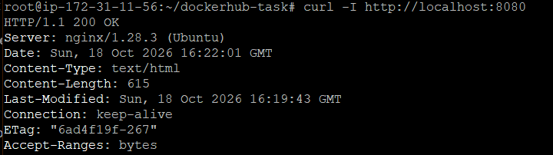

Logged in to docker:
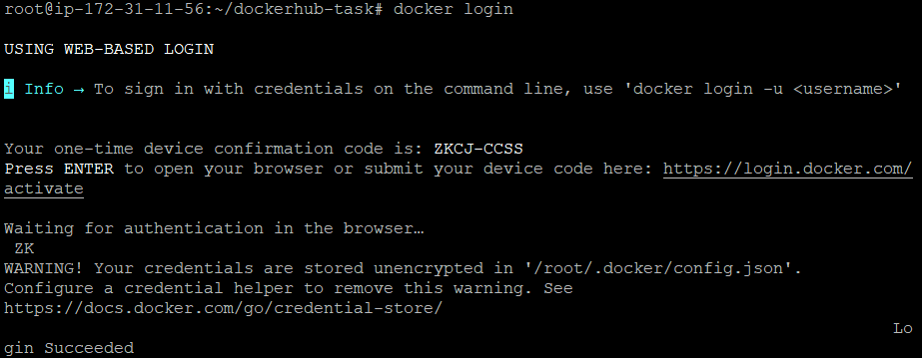

Ngnix Running successfully in another container also:
